EXPT NO: 8 | TRAIN A SIMPLE AUTOENCODER FOR DIMENSIONALITY REDUCTION AND FEATURE LEARNING
DATE: 02.11.2026

PRE-LAB QUESTIONS (PROVIDE BRIEF ANSWERS TO THE FOLLOWING QUESTIONS)

- What is an autoencoder?
An autoencoder is a type of artificial neural network used for learning efficient representations of input data. It is mainly used for dimensionality reduction, feature extraction, data compression, and noise removal. An autoencoder consists of two main components: an encoder and a decoder. The encoder compresses the input data into a smaller representation, while the decoder reconstructs the original data from the compressed representation. It is trained by minimizing the difference between the original input and the reconstructed output.

- What are the roles of the encoder and decoder in an autoencoder?
The encoder and decoder are the two main components of an autoencoder. The encoder takes the original input data and transforms it into a lower-dimensional representation called the latent representation. It extracts the most important features from the input while reducing unnecessary information. The decoder performs the reverse operation by taking the compressed representation and reconstructing the original input. Together, these components help the autoencoder learn meaningful features and reproduce the input data as accurately as possible.

- What is dimensionality reduction?
Dimensionality reduction is the process of reducing the number of features or variables in a dataset while preserving its important information. It helps simplify complex datasets, reduce storage requirements, improve computational efficiency, and remove unnecessary or redundant features. In an autoencoder, dimensionality reduction is achieved by compressing the input data into a smaller latent representation. For example, a 28 × 28 MNIST image contains 784 pixel values, which can be reduced to a smaller representation of 32 features.

- What is meant by latent representation or latent space?
Latent representation is a compressed form of the original input data that contains its most important features. It is generated by the encoder of an autoencoder. Latent space refers to the lower-dimensional space in which these compressed representations are stored. Instead of keeping all the original input values, the model learns to represent the essential information using fewer features. For example, an MNIST image containing 784 input values can be represented using only 32 latent features, making the data easier to process and analyze.

- Why is reconstruction loss used when training an autoencoder?
Reconstruction loss is used to measure the difference between the original input data and the output reconstructed by the autoencoder. It helps the model understand how accurately it can reproduce the input after compression. During training, the model adjusts its weights and biases to minimize this loss. Common reconstruction loss functions include Mean Squared Error (MSE) and Binary Cross-Entropy. A lower reconstruction loss indicates that the reconstructed output is closer to the original input, meaning the autoencoder has learned a better representation of the data.

AIM
To implement and train a simple autoencoder using a dataset such as MNIST, learn a lower-dimensional representation of the input data, and evaluate the model by reconstructing the input samples and visualizing their latent representations.

SOFTWARE REQUIREMENTS
- Python
- TensorFlow / Keras
- Google Colab or Jupyter Notebook
- GitHub
- NumPy
- Matplotlib
- Pandas (optional)

OBJECTIVES
Students will be able to:
- Understand the architecture and working of autoencoders.
- Differentiate between the encoder, latent representation, and decoder.
- Prepare and preprocess a dataset for autoencoder training.
- Build an autoencoder using appropriate neural network layers.
- Train the model using reconstruction loss.
- Perform dimensionality reduction and extract latent features.
- Visualize original and reconstructed samples.
- Evaluate reconstruction performance using loss values and visual inspection.

PROCEDURE
PART A: DATASET PREPARATION AND PREPROCESSING
Perform the following tasks:
- Load the MNIST handwritten digit dataset using TensorFlow/Keras.
- Explore the dataset and check the number of training and testing images and their dimensions.
- Display sample images from the dataset.
- Convert pixel values to floating-point values and normalize them to the range [0, 1].
- Flatten each 28 × 28 image into a 784-dimensional input vector for a basic dense autoencoder.
- Prepare training and testing data. Use the input images as both input and target output because the autoencoder learns to reconstruct its input.
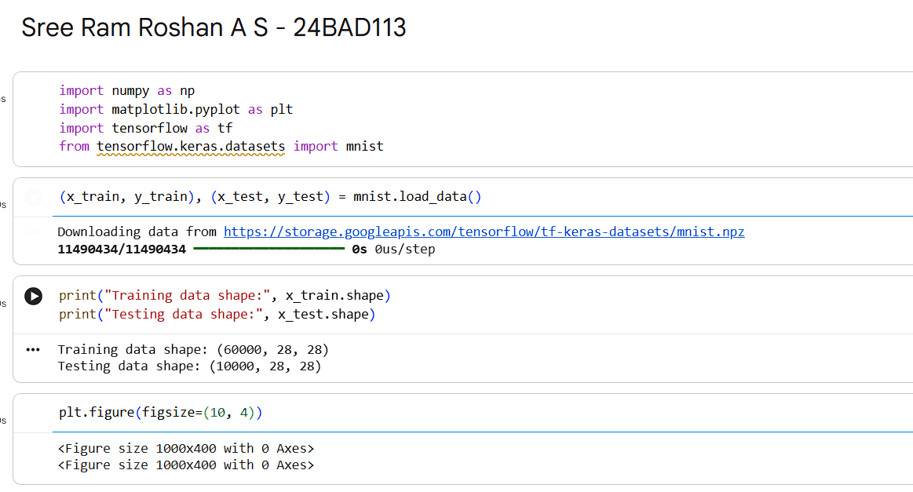
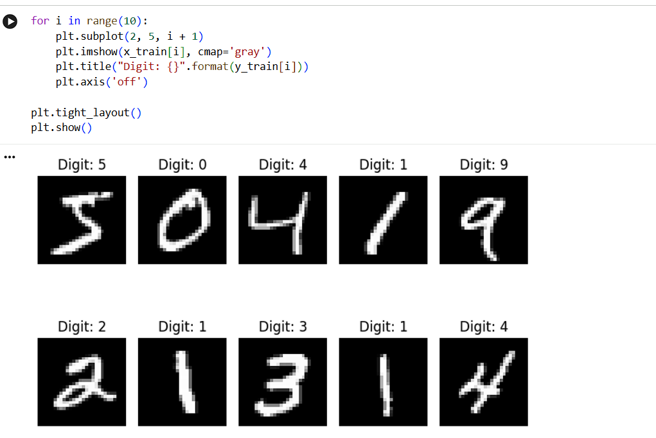
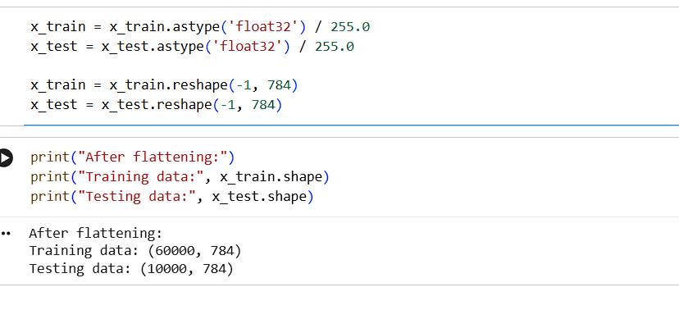

PART B: IMPLEMENTING THE ENCODER AND DECODER
Perform the following tasks:
- Define the input layer with 784 features.
- Build the encoder using one or more Dense layers to map the input to a smaller latent dimension, such as 32 features.
- Build the decoder using Dense layers to map the latent representation back to 784 output values.
- Use suitable activation functions, such as ReLU for hidden layers and Sigmoid for the final layer.
- Combine the encoder and decoder into a single autoencoder model.
- Display the encoder, decoder, and autoencoder model summaries.

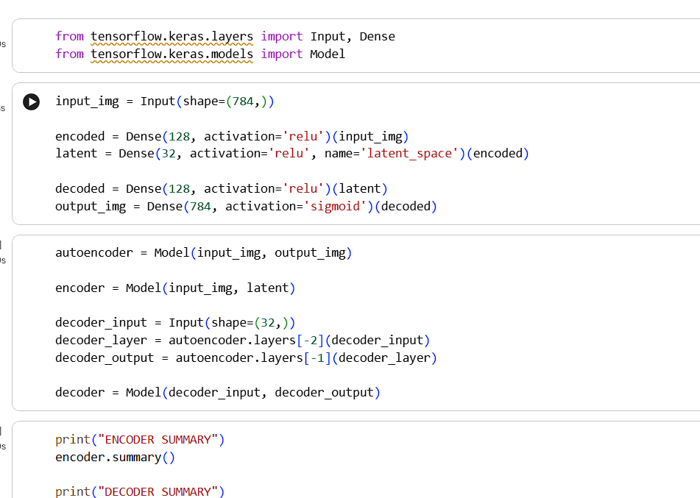
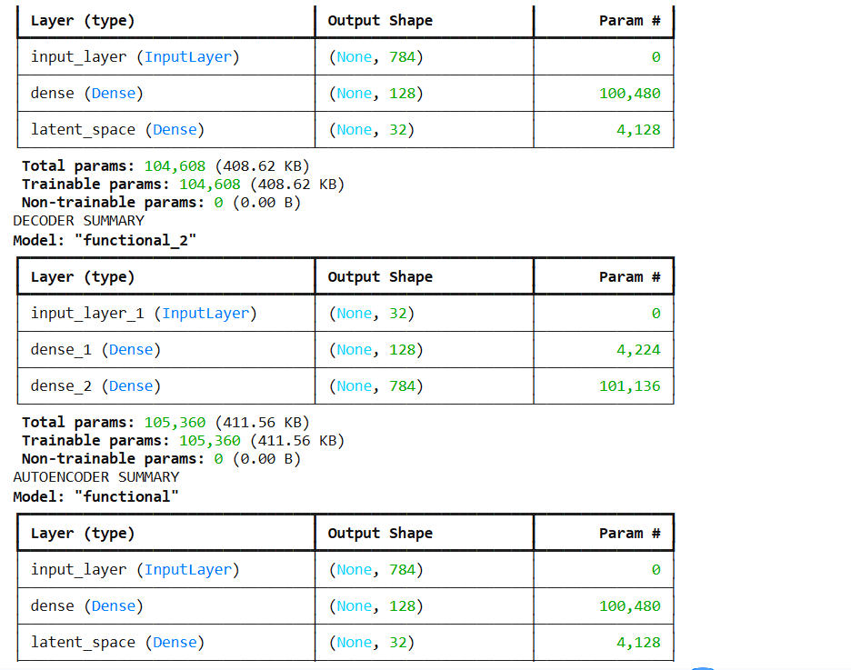

PART C: COMPILING AND TRAINING THE AUTOENCODER
Perform the following tasks:
- Compile the autoencoder using an optimizer such as Adam.
- Select an appropriate reconstruction loss, such as binary cross-entropy or mean squared error.
- Train the model by supplying the input images as both input data and target data.
- Use a suitable batch size and number of epochs. For example, use a batch size of 256 and 10 epochs.
- Validate the model using the test dataset or a validation split.
- Record training and validation loss for each epoch.
- Plot the training and validation loss curves to observe the reconstruction performance.

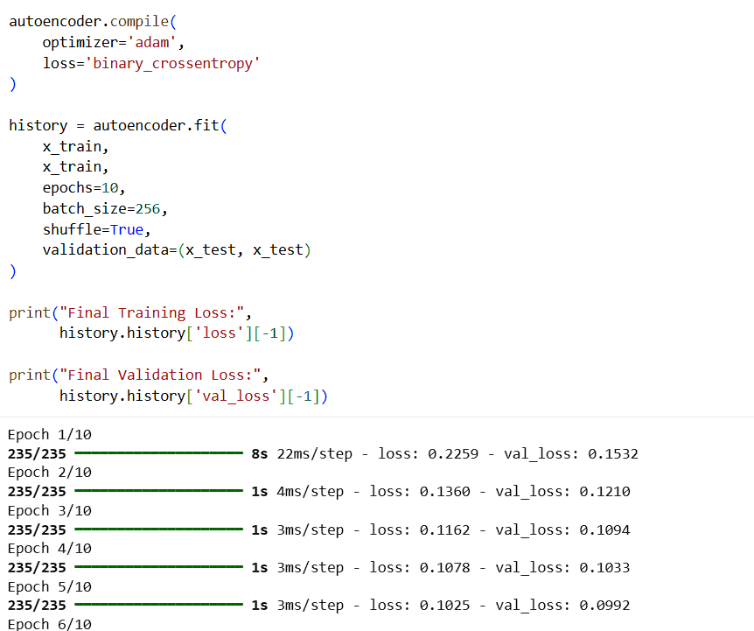
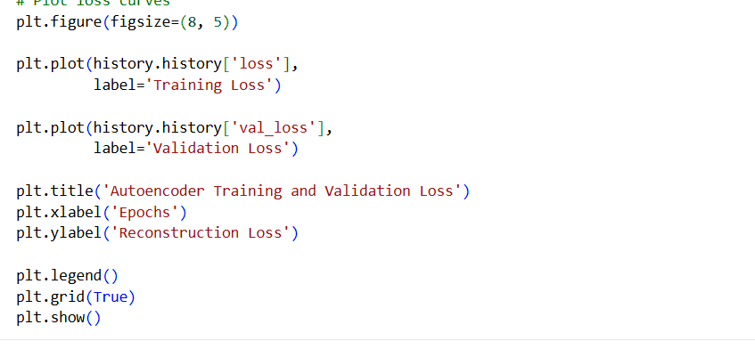

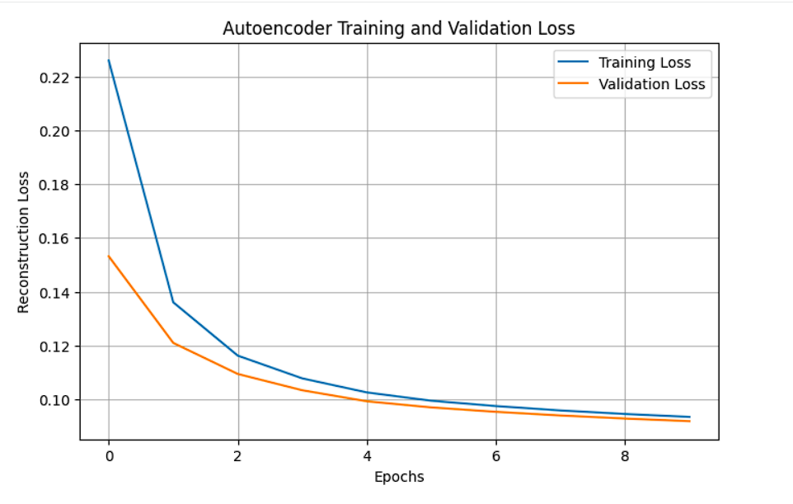

PART D: DIMENSIONALITY REDUCTION, FEATURE LEARNING AND RECONSTRUCTION
Perform the following tasks:
- Use the trained encoder to convert test images into lower-dimensional latent feature vectors.
- Display the original input dimension (784) and latent dimension (for example, 32).
- Pass the latent vectors through the decoder to reconstruct the images.
- Display original images and their corresponding reconstructed images side by side.
- Compare the original and reconstructed images and comment on the information retained or lost.
- Optionally, use PCA or t-SNE to visualize latent features in two dimensions, if covered in the course.
- Save the trained model or reconstructed images if required.

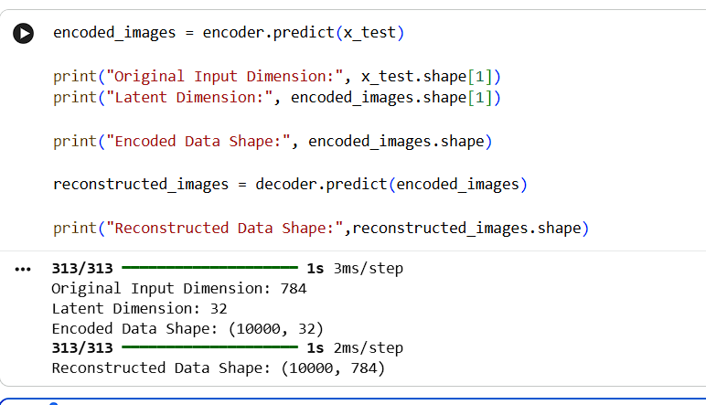

EXPECTED OUTCOME
Students will understand the architecture and working of a simple autoencoder and the roles of its encoder, latent representation, and decoder. They will learn to preprocess data, train the model using reconstruction loss, reduce input dimensionality, and extract compact latent features. They will evaluate the autoencoder by examining training and validation loss and comparing original images with reconstructed images.

POST-LAB QUESTIONS (PROVIDE BRIEF ANSWERS TO THE FOLLOWING QUESTIONS)

- What is the main purpose of an autoencoder?
The main purpose of an autoencoder is to learn a compressed representation of input data and reconstruct the original data from that representation. It is commonly used for dimensionality reduction, feature extraction, data compression, and noise removal. The encoder reduces the input into a smaller set of important features, while the decoder uses those features to recreate the original data. In this experiment, the autoencoder is trained using the MNIST handwritten digit dataset to learn compact representations of images and reconstruct them with minimum information loss.

- How do the encoder and decoder differ?
The encoder and decoder perform opposite operations in an autoencoder. The encoder converts the original input data into a smaller, compressed representation by extracting important features and reducing dimensionality. The decoder takes this compressed representation and attempts to reconstruct the original input data. For example, in this experiment, the encoder converts a 784-dimensional MNIST image into a 32-dimensional latent vector, while the decoder converts the 32-dimensional vector back into a 784-dimensional reconstructed image. Both components work together to minimize reconstruction error.

- What is a latent representation?
A latent representation is a compact, lower-dimensional representation of the original input data produced by the encoder. It contains the most important information and features required to reconstruct the input. It reduces the amount of data that needs to be processed while attempting to preserve meaningful patterns. In this experiment, the original MNIST images have 784 pixel values, but the encoder compresses them into 32 latent features. These features represent important characteristics of handwritten digits and are used by the decoder for image reconstruction.

- How does an autoencoder perform dimensionality reduction?
An autoencoder performs dimensionality reduction through its encoder network. The encoder takes high-dimensional input data and passes it through neural network layers to produce a smaller latent representation. During training, the model learns to preserve important information while reducing the number of features. The decoder then uses this compressed representation to reconstruct the original input. In this experiment, each MNIST image containing 784 features is compressed into 32 features. Thus, the autoencoder reduces dimensionality while retaining important visual characteristics of handwritten digits.

- Why are the input images also used as target outputs during training?
In an autoencoder, the main objective is to reconstruct the original input data as accurately as possible. Therefore, the same input images are used as both input data and target outputs during training. The encoder compresses the images into latent representations, and the decoder attempts to recreate the original images. The reconstruction loss compares the original images with the reconstructed images and updates the model parameters to reduce errors. This training method helps the autoencoder learn useful features without requiring separate output labels.

- What does reconstruction loss measure?
Reconstruction loss measures the difference between the original input data and the reconstructed output generated by an autoencoder. It indicates how accurately the model can reproduce the input after passing it through the encoder and decoder. A smaller reconstruction loss means that the reconstructed data is closer to the original data, while a larger loss indicates greater differences. Common loss functions include Mean Squared Error (MSE) and Binary Cross-Entropy. During training, the optimizer minimizes reconstruction loss to improve the performance and accuracy of the autoencoder.

- What may happen if the latent dimension is too small?
If the latent dimension is too small, the autoencoder may not have enough capacity to store all the important information from the original input data. As a result, some important features and details may be lost during compression. This can lead to poor reconstruction quality, blurry images, and increased reconstruction loss. For example, if an MNIST image containing 784 features is compressed into only 2 or 3 features, the decoder may struggle to reconstruct the original handwritten digit accurately. Therefore, an appropriate latent dimension should be selected.

- Mention one real-world application of autoencoders.
One important real-world application of autoencoders is image denoising. In this application, an autoencoder is trained to remove unwanted noise from images and produce cleaner versions. The encoder extracts useful features from noisy images, while the decoder reconstructs the image with reduced noise. Autoencoders are also used in anomaly detection, data compression, medical image processing, and feature extraction. For example, in medical imaging, autoencoders can help improve image quality by reducing noise and preserving important structures for further analysis.

SUGGESTIONS FOR DATASETS
- MNIST Handwritten Digits – https://www.tensorflow.org/datasets/catalog/mnist
- Fashion-MNIST – https://www.tensorflow.org/datasets/catalog/fashion_mnist
- CIFAR-10 – https://www.tensorflow.org/datasets/catalog/cifar10 (requires adapting the model for image inputs)

ASSESSMENT
Description | Max Marks | Marks Awarded
Pre Lab Exercise | 5
In Lab Exercise | 10
Post Lab Exercise | 5
Viva | 10
Total | 30
Faculty Signature

